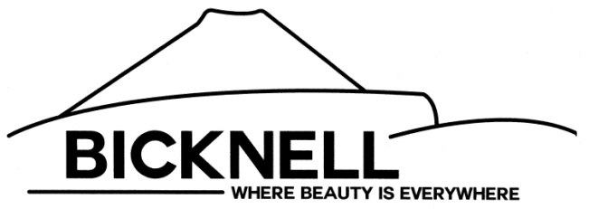
BICKNELL TOWN INCORPORATED
P.O. BOX 96
64 West 100 North
BICKNELL, UTAH 84715

BICKNELL TOWN WORK MEETING AGENDA
February 29, 2024
7:00 P.M.

- OPEN MEETING/ROLL CALL
- PUBLIC COMMENTS
- ITEMS TO DISCUSS
- EMS Resolution
- July 24th Celebration
- Accessory Dwelling Unit Ordinance
- Disposal of Town Owned Property Ordinance No. 03-07-2024
- Roads
- CLOSED SESSION (if needed) as permitted by Utah Code Annotated Section 52-4-205(1)(a)
- ADJOURNMENT

Kelsey Brinkerhoff, Town Clerk

