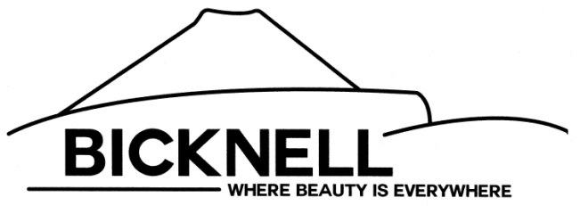
BICKNELL TOWN INCORPORATED
P.O. BOX 96
BICKNELL, UTAH 84715

BICKNELL TOWN WORK MEETING AGENDA
31 MARCH 2022
7:00 P.M.

I. OPEN MEETING/ROLL CALL
II. ITEMS TO DISCUSS
A. Budget
B. Impact Fees
C. Fire District
D. Water Project

III. ADJOURNMENT

Kelsey Brinkerhoff, Town Clerk

This notice was posted at the following places
at approximately 10:00 am, 30 March 2022:

Bicknell Town Hall
US Postal Service
Blackburn’s Propane

________________________________
ATTEST: Kelsey Brinkerhoff, Town Clerk

